**Employee Face Detection using opencv and Python-Tkinter**

**Output for this Case Study :-**

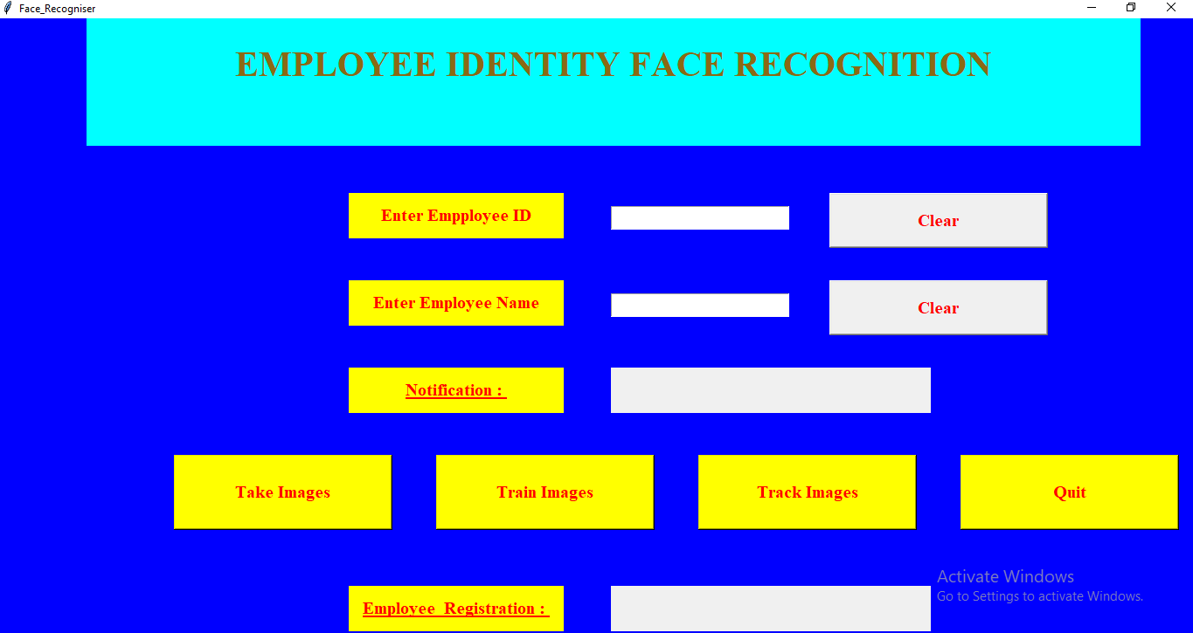

**My Approach:-**

**Section 1: Dataset Collection**

**#Necessary imports**

import tkinter as tk  
from tkinter import Message **,**Text  
import cv2**,**os  
import shutil  
import csv  
import numpy as np  
from PIL import Image**,** ImageTk  
import pandas as pd  
import datetime  
import time  
import tkinter.ttk as ttk  
import tkinter.font as font

**#GUI for Employee using Tkinter :-**

lbl = tk.Label(window**,** text="Enter Empployee ID"**,**bg="yellow"**,**width=**20 ,**height=**2 ,**fg="red" **,**font=('times'**, 15,** ' bold ') )  
lbl.place(x=**400,** y=**200**)  
  
txt = tk.Entry(window**,**width=**20 ,**fg="red"**,**font=('times'**, 15,** ' bold '))  
txt.place(x=**700,** y=**215**)  
  
lbl2 = tk.Label(window**,** text="Enter Employee Name"**,**bg="yellow"**,**width=**20 ,**fg="red" **,**height=**2 ,**font=('times'**, 15,** ' bold '))  
lbl2.place(x=**400,** y=**300**)  
  
txt2 = tk.Entry(window**,**width=**20 ,**fg="red"**,**font=('times'**, 15,** ' bold ') )  
txt2.place(x=**700,** y=**315**)

* **Before recognizing face we have to detect it using Haar Cascade algorithm**
* **Will process RGB image into gray image(it’s a binary code image)**
* **Will iterate loop over images to extract values/co-ordinates and frame the rectangle box by capturing the image randomly and save in training image directory by cropping it and save the Id and Name of Registered Employee**
* **Will create csv file and append all the employee details while registering through cam**

**Section 3 : Dataset Training**

* **Will train saves images of employee when have to compare by fetching them where we have stored them during Registration**
* **Will use special library function from cv2 LBPHFaceRecognition algorithm to define each image and train them.**

**Section 4: Face Recognition**

* **Will capture image and again convert into grayscale and extract face properties/scaling using detectMultiScale() function(it will detect gray image by certain scaling factor)**
* **And again will draw the rectangle box by extracting all 4 co-ordinates of detected face by cropping**
* **Will also store date,timestamp of Registered Employee and compare image captured through Live webcam with previous stored data points.**
* **If it matches then it will give output with [Id, Name] else will give the output as Unkown Face/Not Found**